**Task 3**

**Project: Event Management System using PostgreSQL.**

Objective: To develop the application that allows users to create and manage events, track attendees, and handle event registrations efficiently. The project will include the following tasks:

**1. Database Creation**

Create a database named "EventsManagement." Create tables for Events, Attendees, and Registrations.

Events- Event_Id, Event_Name, Event_Date, Event_Location, Event_Description

Attendees- Attendee_Id, Attendee_Name, Attendee_Phone, Attendee_Email, Attendee_City

Registrations-Registration_id, Event_Id, Attendee_Id,Registration_Date,Registration_Amount.

The FOREIGN KEY constraint in the Registrations table references the Event_Id column in the Events table and the Attendee_Id column in the Attendees table.

CREATE DATABASE EventsManagement;

CREATE TABLE Events (

Event_Id SERIAL PRIMARY KEY,

Event_Name TEXT NOT NULL,

Event_Date DATE NOT NULL,

Event_Location TEXT NOT NULL,

Event_Description TEXT

);

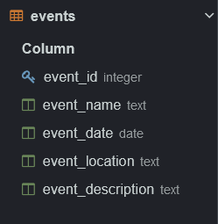

CREATE TABLE Attendees (

Attendee_Id SERIAL PRIMARY KEY,

Attendee_Name TEXT NOT NULL,

Attendee_Phone NUMERIC NOT NULL,

Attendee_Email TEXT NOT NULL,

Attendee_City TEXT NOT NULL

);

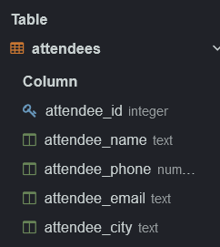

CREATE TABLE Registrations (

Registration_Id SERIAL PRIMARY KEY,

Event_Id INT NOT NULL,

Attendee_Id INT NOT NULL,

Registration_Date DATE NOT NULL,

Registration_Amount NUMERIC NOT NULL,

FOREIGN KEY (Event_Id) REFERENCES Events(Event_Id),

FOREIGN KEY (Attendee_Id) REFERENCES Attendees(Attendee_Id)

);

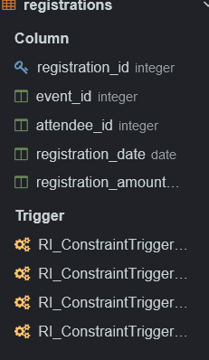

**2. Data Creation**

Insert some sample data for Events, Attendees, and Registrations tables with respective fields.

INSERT INTO Events (Event_Id, Event_Name, Event_Date, Event_Location, Event_Description)

VALUES

(1, 'Tech Conference', '2024-08-15', 'New York', 'Annual tech conference featuring latest trends.'),

(2, 'Music Festival', '2024-09-20', 'Los Angeles', 'Three-day music festival with top artists.'),

(3, 'Business Summit', '2024-07-10', 'London', 'Gathering of global business leaders.');

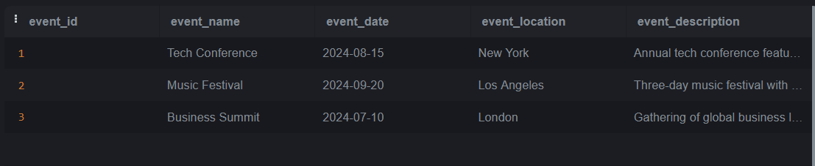

INSERT INTO Attendees (Attendee_Id, Attendee_Name, Attendee_Phone, Attendee_Email, Attendee_City)

VALUES

(1, 'John Doe', '1234567890', 'john.doe@example.com', 'New York'),

(2, 'Jane Smith', '9876543210', 'jane.smith@example.com', 'Los Angeles'),

(3, 'Michael Johnson', '5554443333', 'michael.johnson@example.com', 'London');

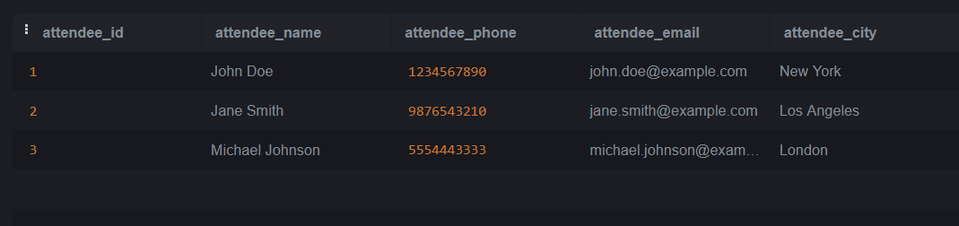

-- Inserting sample data into Registrations table

INSERT INTO Registrations (Event_Id, Attendee_Id, Registration_Date, Registration_Amount)

VALUES

(1, 1, '2024-08-01', 100.00),

(2, 2, '2024-09-01', 150.00),

(3, 3, '2024-07-01', 200.00);

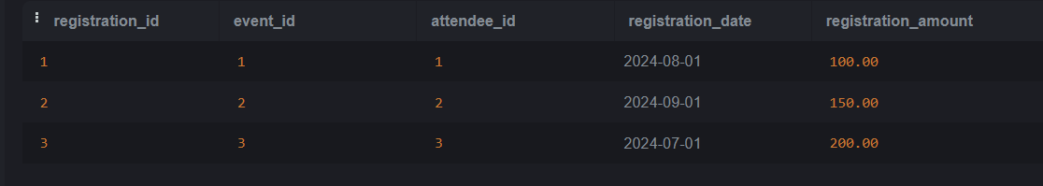

**3. Manage Event Details**

a) Inserting a new event.

-- Inserting a new event without specifying Event_Id (assuming Event_Id is SERIAL)

INSERT INTO Events (Event_Name, Event_Date, Event_Location, Event_Description)

VALUES ('Fashion Show', '2024-10-15', 'Paris', 'Annual fashion event showcasing latest trends.');

b) Updating an event's information.

UPDATE Events

SET Event_Location = 'New York',

Event_Description = 'Annual tech conference featuring latest technologies and speakers.'

WHERE Event_Id = 1;

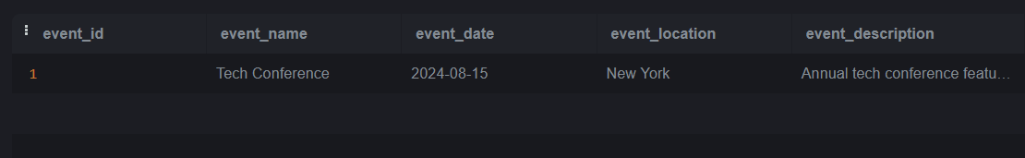

c) Deleting an event.

DELETE FROM Events

WHERE Event_Id = 1;

**4) Manage Track Attendees & Handle Events**

a) Inserting a new attendee

-- Inserting a new attendee with Attendee_Id specified

INSERT INTO Attendees (Attendee_Id, Attendee_Name, Attendee_Phone, Attendee_Email, Attendee_City)

VALUES (6, 'John Doe', '+1-234-567-8901', 'john.doe@example.com', 'New York');

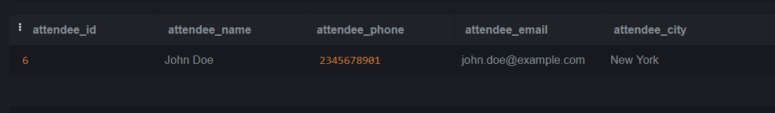

b) Registering an attendee for an event.

INSERT INTO Registrations (Event_Id, Attendee_Id, Registration_Date, Registration_Amount)

VALUES (1, 1, '2024-06-01', 100.00);

**Output:**

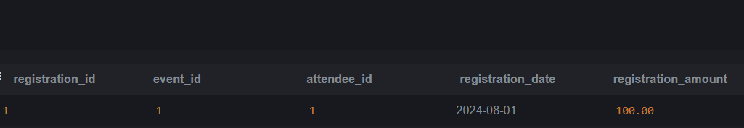

5.Develop queries to retrieve event information, generate attendee lists, and calculate event attendance statistics.

**Retrieve Event Information**

To retrieve all information about events from the Events table:

SELECT * FROM Events;

Output:

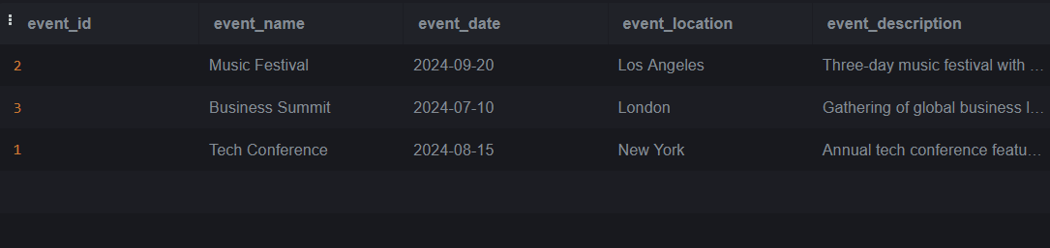

**Generate Attendee Lists**

SELECT a.Attendee_Id, a.Attendee_Name, a.Attendee_Phone, a.Attendee_Email, a.Attendee_City

FROM Attendees a

JOIN Registrations r ON a.Attendee_Id = r.Attendee_Id

WHERE r.Event_Id = 1;

Output:

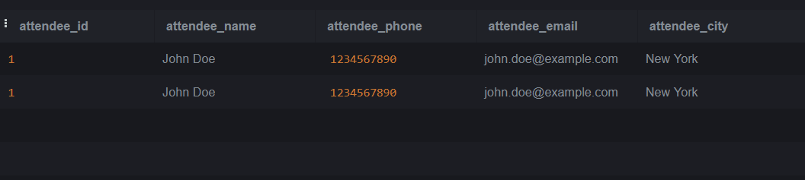

**Calculate Event Attendance Statistics**

SELECT e.Event_Name, COUNT(r.Registration_Id) AS Attendee_Count

FROM Events e

LEFT JOIN Registrations r ON e.Event_Id = r.Event_Id

GROUP BY e.Event_Name;

